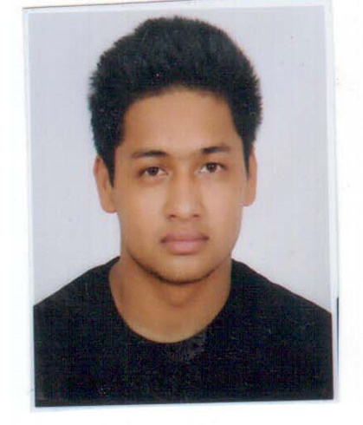**CUURRICULUM VITE**

**CAREER OBJECTIVE:**

To contribute my services in a reputable organization bearing in a healthy environment. Where I can utilize my skills and energy only to accomplished one challenge after another with complete dedication, sincerity and a goal oriented attitude.

**PERSONAL DRTAILES**

Name : Mr. Sujan Bahadur Bhandari

Date of Birth : 27/11/1995

Marital Status : Unmarried

Father’s Name : Mr. Mohan bahadur Bhandari

Mother Name : Laxmi Bhandari

Religion : Hindu

Nationality : Nepali

Sex : Male

Permanent Address : Narayan Municipality-7 Dailekh

Temporary Address : Naya Thimi Bhaktapur

Age : 22 years

Phone No. : +9779848001005

Email : sujanbhandari95@gmail.com

Passport No. : 09602353

Language : Nepali,English,Hindi

Hobbies : writing feature article, study histrical book n Nobel, research social part of human life style in Nepal

Height : 5.7ft

Computer Knowledge:Basic course

**Experienced:** working at bhaktapurnews.com

Member at Rafat sanchar club

2 years worked at Dabab weekly

3 years worked at Bhaktapurnews.com weekly

Rj training at radio n mass communation

2years waiter (10 Nov.2014 to 25 Dec.2016 In “NIRVANA GARDEN-HOTEL” THAMEL,CHHETRAPARTY, KATHMANDU,NEPAL).

**Academic Qualification:**

|  |  |  |  |
| --- | --- | --- | --- |
| Degrees | Institute | Year | Division |
| S.L.C | Shree Basanta Higher Secondary School Kimugau,Dailekh | 2066 | 2nd |
| +2 | Shree Tribhuwan Higher Secondary School Naya Bazar Dailekh | 2070 | Pass |
| Bachelor | Sandipani Community College Koteshwor Kathmandu | 2071 | Running |

**Declaration:**

I hereby declare that the above mentioned statement is correct and true to the best of my knowledge and believe.